Network Protocol And Security - Advanced

Karthik B

2320040057

ECE

IMPLEMENTATION

Login into Your Kali Linux machine and Targeted Windows 10 Machine from Oracle Virtual Box

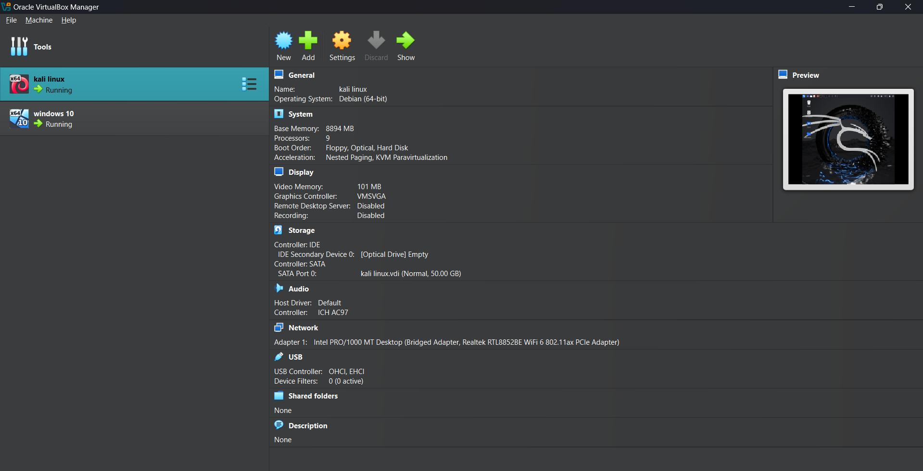

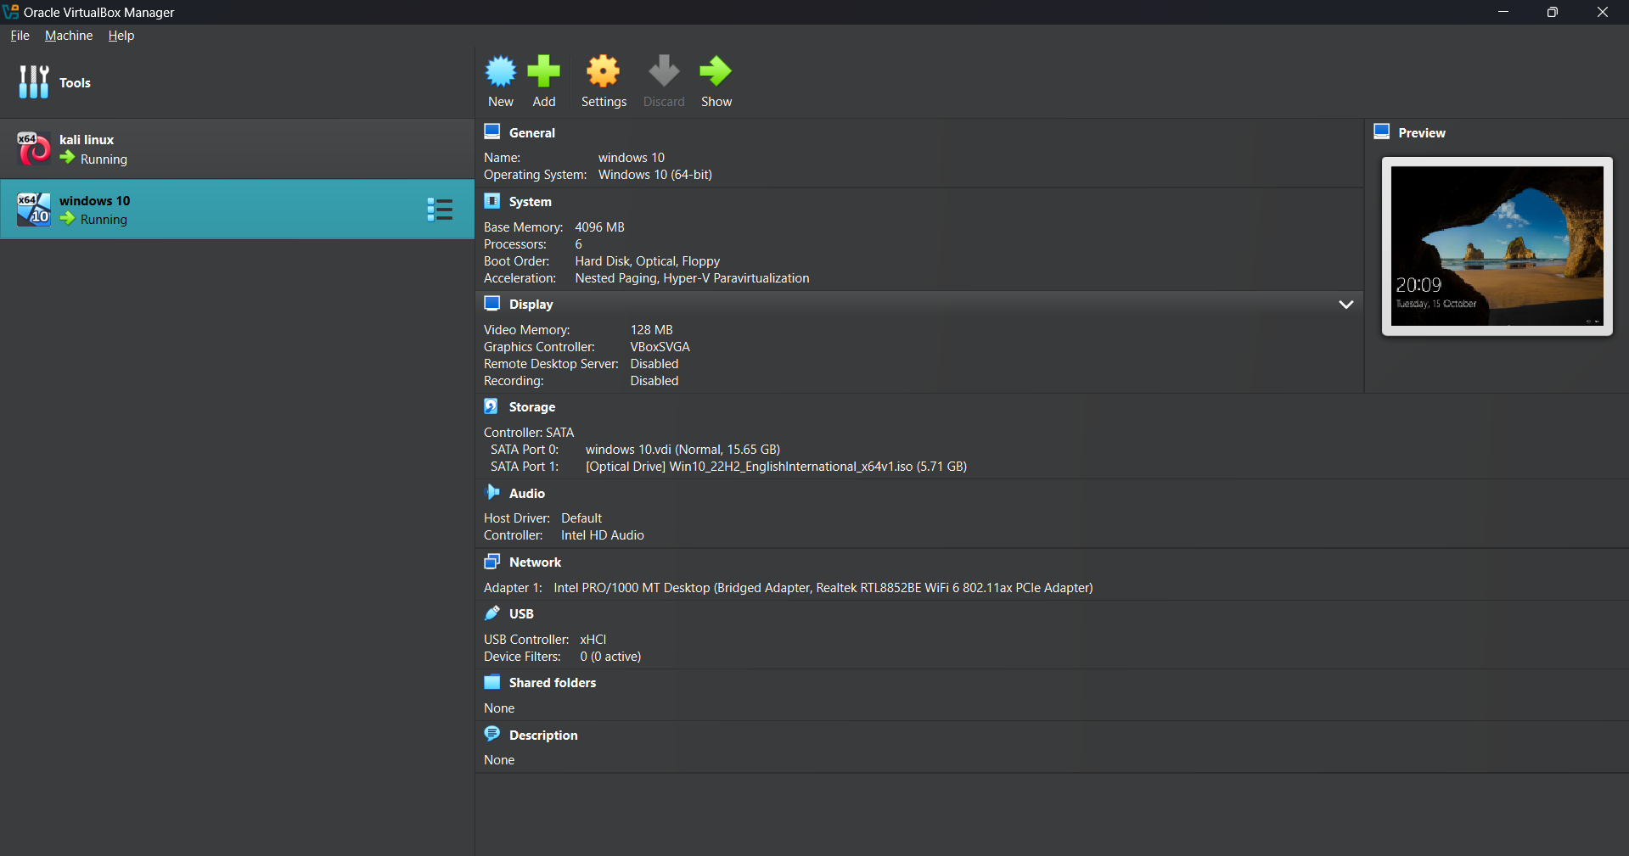

Make Sure that both are given ample amount of space and memory to run both of them properly

Now Let us set up our target machine i.e. windows 10

Machine

Open settings

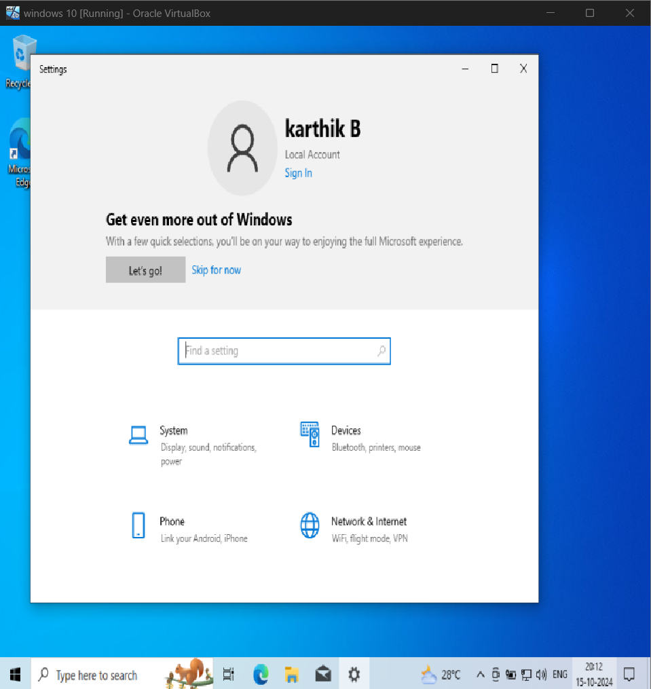

Open Windows Security and disable Firewall and windows security settings

Now

Click windows+R

That will open Run window enter cmd and press ok

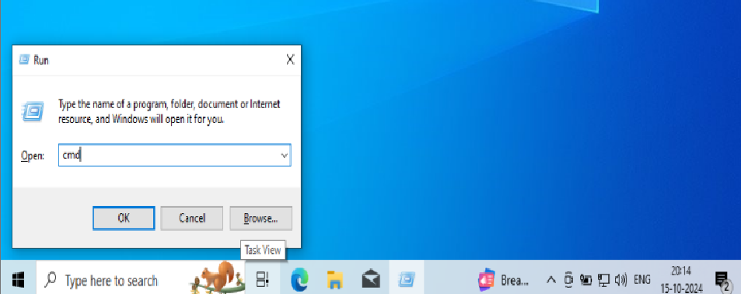

Now Enter “ipconfig” in the terminal

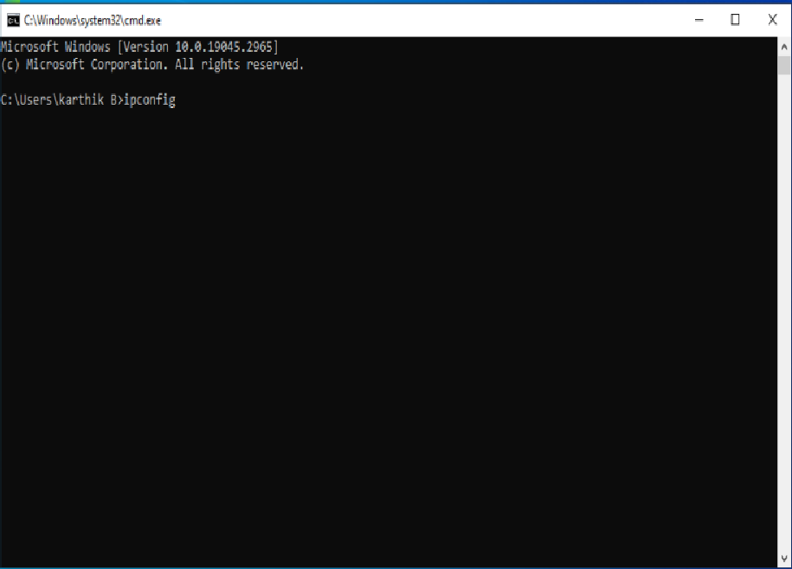

Press Enter

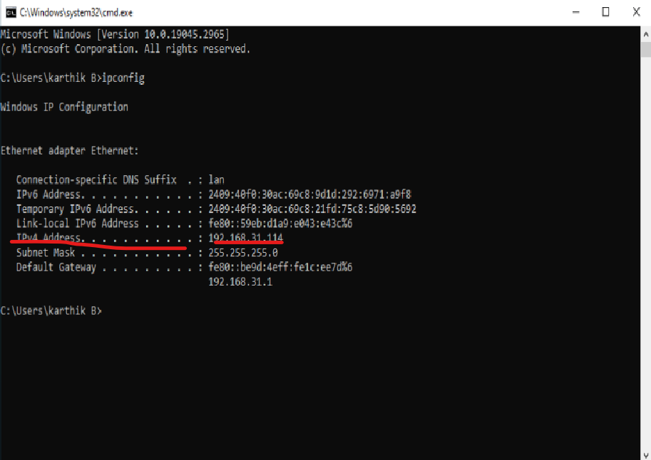

Check for the IPV4 address highlighted above

Now let us come back to the Kali machine

Testing

Now we are entering into testing Phase where we work on kali machine

For this Testing phase we are Testing using CVE-2020-0796 file that is used to crack the windows 10 machine

We need to open command prompt in kali and first perform a scan to check whether the kali machine is connected with windows 10 target machine or not

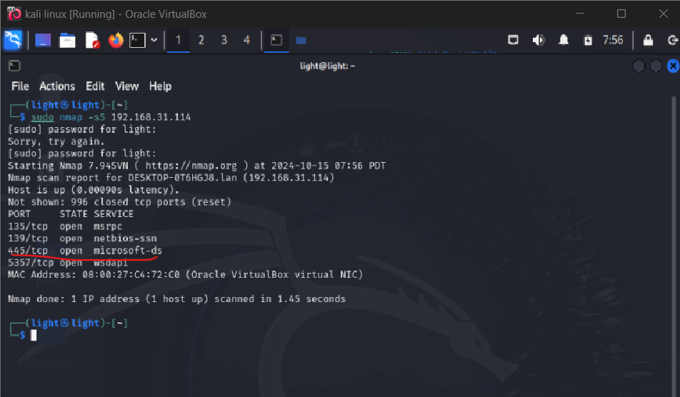

We have to check whether the port 445/tcp is open or not

We can perform the attack only when it is open

Now download the required files from git hub

And save it on desktop as

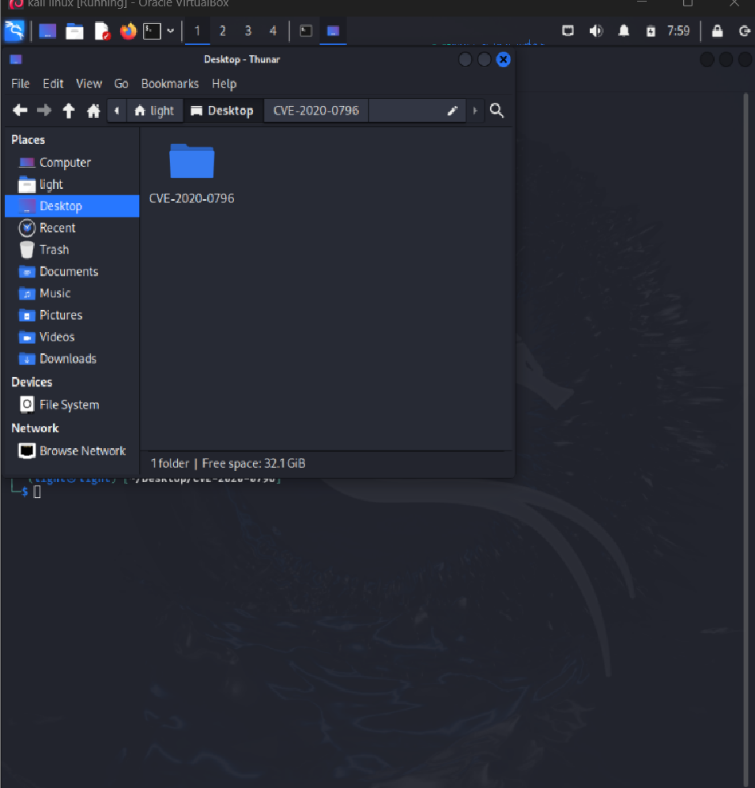

Now follow the steps as given in below as follows

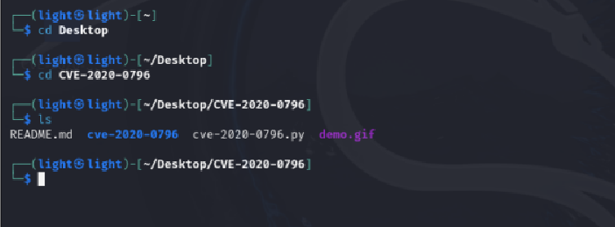

Now we have to check weather the target machine is vulnerable or not

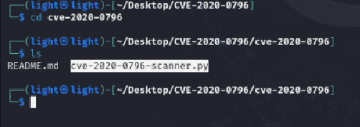

Now we are going to run the scanner to check whether the windows 10 system is vulnerable or not

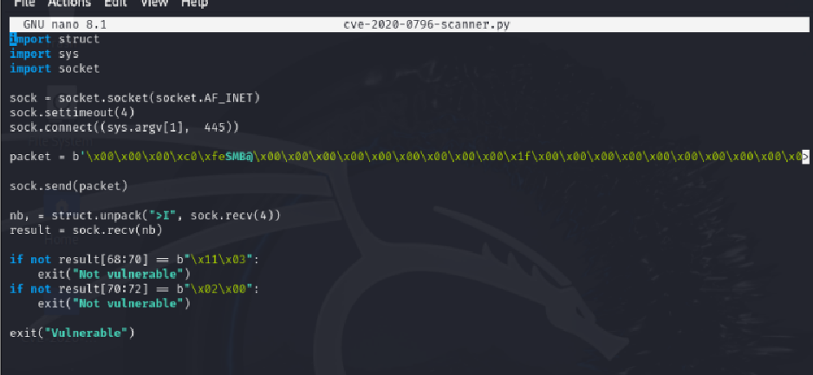

To run the check we need to download python 3 in advanced and run this 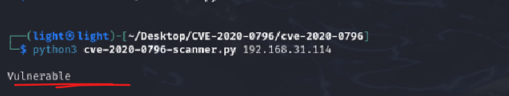

Once we confirm it is vulnerable we go for attacking

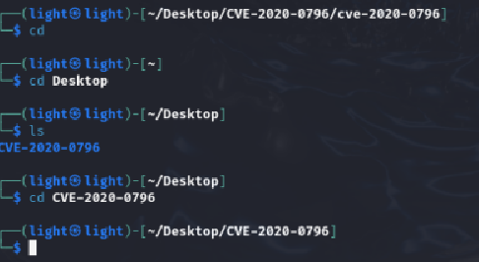

Follow the above steps to navigate to the file where attacking takes place

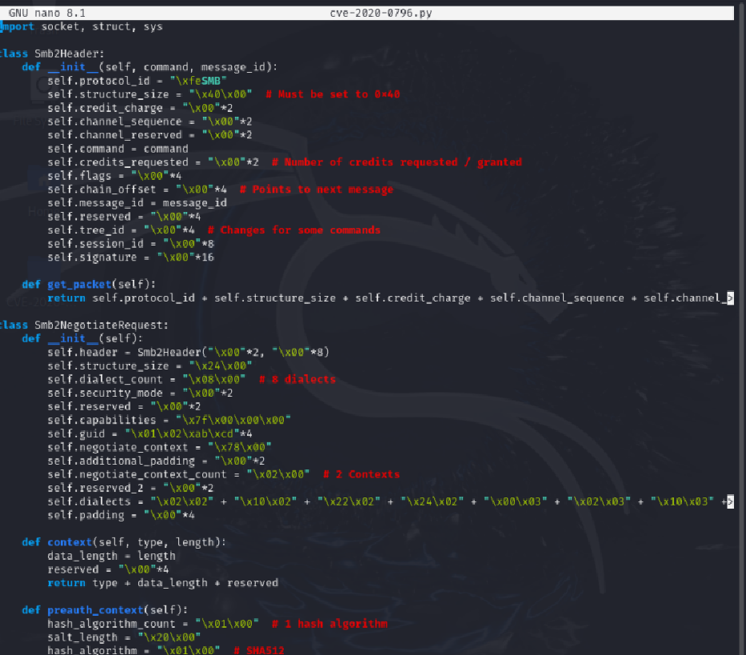

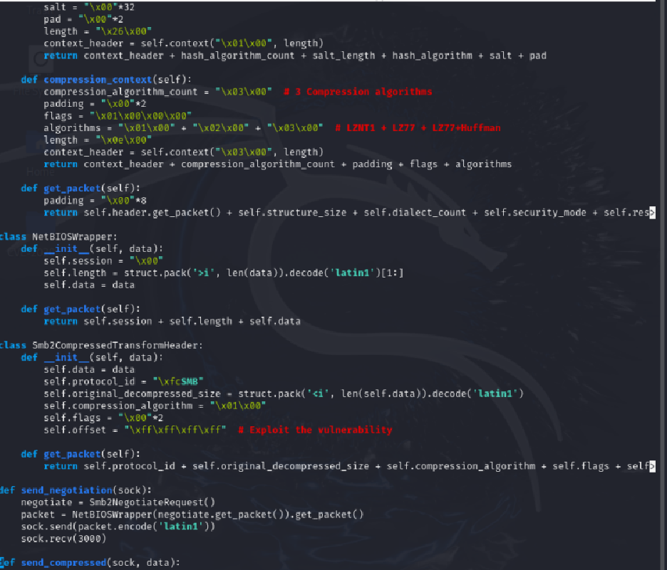

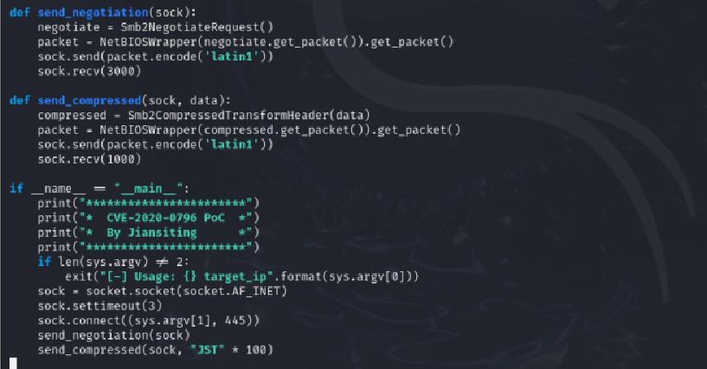 This is the python program for the attacking of the windows 10 machine

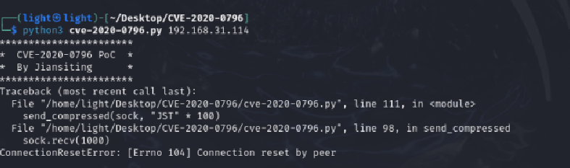

Enter the python 3 command with the file name and the Ip address of the target machine and enter you must see the results in not time but there seems to be a problem with the connection of the windows 10 machine as the machine is blocking the access of the kali machine even though it is vulnerable